BOXWOOD GARDEN CLUB
January Newsletter
“Anyone who thinks gardening begins in the spring and ends in the fall is missing the best part of the whole year; for gardening begins in January with the dream.” Josephine Nuese

Happy New Year Boxwood Members! I hope you all had a wonderful holiday season and were able to avoid all of the viruses going around! I’m still waiting for some snow to blanket my garden—it’s so beautiful all white! But I’ve found time during these cold days to peruse the piles of gardening catalogs to select some plants, seeds and bulbs so I’ll be ready to plant when winter breaks. As a matter of fact, I enjoy planting so much that I’ve rented space at the Humphrey-Calder Community Garden for the year! Hopefully, I’ll have lots of blooms for Garden Week!

Speaking of bulbs, my copy of Brent and Becky’s bulbs arrived today with some beautiful gladiolas, dahlias, lilies and many other beautiful specimens. If you plan to order, please go to www.bloominbucks.com to place your order. Scroll down on participating organizations tab and select “Boxwood” and we will get a percentage of the sale!! It’s a win-win!

We have a busy spring coming up and several REALLY GOOD speakers. Mark your calendars so you won’t miss any of the fun!

RECAP OF HOLIDAY EVENTS
We started the holiday season with our annual Holiday Shopping Event at 5807. We had a terrific turnout and doubled our profits!! Thank you to all who attended and an especially BIG thank you to Joan Sewell and Sharon Moody for arranging this fun evening! The beverages, treats, shopping, comradery and prizes were top notch.

The wreath and arranging workshop was held the first of December and though it was pretty chilly, lots of beautiful designs were made. To be as cold as it was there was a good crowd! Thank you to those who helped create and deliver the beautiful arrangements for our Life Members! (Photos attached)

JANUARY MEETING
We have a very special speaker for our January meeting . On January 24, 2023 at First Presbyterian Church, the world-renowned Gregory Britt of Gregory Britt Designs will be joining us! His topic will be “Using Forced Branches in Spring Arrangements”. Mr. Britt trained in New York then landed in Washington, VA as the floral and event designer for The Inn at Little Washington. In 2018 he opened his own studio in Charlottesville.
As usual, exhibits need to be in place by 9:30 a.m. and our meeting will start at 10:00 a.m. WE WILL BE HAVING A VASE / CONTAINER EXCHANGE—BRING ONE, TAKE ONE!

Artistic:
CLASS I: Landscape Escape: Create an arrangement inspired by the colors or
shapes of your favorite landscape.
CLASS II: Pot-et-Fleur: Use cut plant material to show off 2 or more rooted
plants in a basket or pottery bowl. Moss may cover the top.
Contemporary Floral Styles and Designs, p. 13
Horticulture:
CLASS I: Evergreen Branch
CLASS II: Forced Bulbs
Photography:
CLASS I: A black & white photograph of a frame within a frame of any landscape
that includes a water element.
CLASS II: A color photograph of a landscape with the sunrise or sunset in the
background.

NEW MEMBERS
In November we elected 8 Active Members and 1 Guest Member to our club! There will be a New Member Orientation on Tuesday, January 17, 2023 from 9:30-1:00 at the Kent Valentine House. Please join me in welcoming our new members!

Sarah Crane—5 Banbury Road, Richmond, VA 23221, C-(703)505-8682
sarah.crane.2011@gmail.com

Polly Helm—5310 New Kent Road, Richmond, VA 23225, C(804)551-3110
polly.helm@icloud.com

Jennifer Taylor Hudgins—311 S. Gaskins Road, Richmond, VA 23238 C(804)615-7736
j.hudgens@me.com

Muffy (Martha) Feinour Jamieson—8010 Carriage Lane, Richmond, VA 23229
C (804)349-4604, muffyjamieson@gmail.com

Stephanie Smith Parker—208 Hillwood Avenue, Richmond, VA 23226, C(804)283-1038
Sparker208@verizon.net

Camille Rebecca Robinson—3533 Hanover Avenue, Richmond, VA 23221,
C (804)357-8888, camille@robinsonRVA.com

Lisa Crescentini Tripodi—4304 Kensington Avenue, Richmond, VA 23221,
C (804)387-0786, lisa@tripodifamily.com

Laura Lawson Trevy—8305 Kingsthorpe Terrace, Richmond, VA 23229
C (804)304-7894 laura.trevey@gmail.com

GUEST MEMBER—Lauren Prince—3813 Dover Road, Richmond, VA 2321
C (276)806-1921, wdprince@embarqmail.com

CONSERVATION/LEGISLATIVE NEWS
LEGISLATIVE DAY at the VA General Assembly is TUESDAY. JANUARY 31st!
Every year, the GCV, through us as volunteers, participates in “Legislative Day” to lobby our State Senators and Delegates to put attention on and to vote for Environment conservation and beautification issues that affect our Commonwealth. GCV does this as part of its Mission to conserve, restore and preserve nature for future generations.
Here is the link to the GCV legislative issues of interest:
https://www.gcvirginia.org/warehouse/fm/documents/conservations/GCV%20Advocacy%20for%202023%20Legislative%20Issues.pdf

YOU CAN HELP BY:
1. Writing a letter to each your Delegate and Senator. Please see the following link for a template letter that you can simply fill out and mail or use to draft a personal letter to advocate for environmental issues. https://www.gcvirginia.org/warehouse/fm/documents/conservations/Sample%20Legislator%20EMail%202023.pdf

Here’s how to find out the names of your Representatives:
https://whosmy.virginiageneralassembly.gov/

2. Setting up a meeting with your Representatives. Here are some tips: https://www.gcvirginia.org/warehouse/fm/documents/conservations/How%20to%20Talk%20With%20Your%20Legislator%202023.pdf

3. Registering and attending Legislative Day! Here’s the link to sign up:
https://engage.vcnva.org/event/conservation-lobby-day/e450327

If you’d like more information, please contact Lee Nelson, Boxwood Conservation Chair:
804.380.8680 or
Leemn1959@gmail.com

DAFFODIL DAY—March 28-29, 2023
The 89th GCV Daffodil Day, “Here Comes the Sun” will be held at the Norfolk Botanical Gardens on March 28-29. This is one of the nation’s largest daffodil shows and will consist of approximately 2,000 daffodil species and 40 floral arrangements. If you would like to exhibit, registration is now online at www.gcvirginia.org. Our club has registered to enter both the Inter Club Artistic Division and the Inter Club Horticulture Division. In addition, many of your club members will be attending and exhibiting and if you’ve never seen the Norfolk Botanical Gardens, they are definitely worth a visit! Find a friend and come join us!

ENDOWMENT
Thank you to everyone who made a contribution to the Endowment Fund last year. If you would still like to make a donation please mail your checks to Nella Timmons—3440 Old Gun Road E., Midlothian, VA 23113

DATES TO REMEMBER
--January 17, 2023—New Member Orientation—9:30-1:00—Kent Valentine House
--January 24, 2023—January Membership Meeting—First Presbyterian Church
--February 28, 2023—February Membership Meeting—Wilton House Museum
--March 21, 2023—March Membership Meeting—All Saints Episcopal
--March 28-29, 2023—Daffodil Day-Norfolk Botanical Gardens
--April 15-22, 2023—HISTORIC GARDEN WEEK
--May 23, 2023—Boxwood Annual Meeting—bus trip to Stratford Hall
--June 2-4, 2023—“Arranging for the Joy of It”—Shrine Mont, VA
--June 7-8, 2023—GCV Horticulture Field Day-Williamsburg, VA
--June 21, 2023—GCV Lily Show—Orange, VA

MEMBERSHIP UPDATES

Over the holidays , Boxwood lost its Honorary Member, Mr. Charles (Charlie) Reed. Charlie and Ann Reed are both long time members of our club. They have both been very generous in sharing their love for flowers (especially delphiniums and poppies) and their gardening talents. I have heard that Charlie was ALWAYS in his garden—a true gardener! The Reeds were also very kind to open their barn for our workshops, to host GCV dinners and to open their home for Garden Week. Many of us attended his service at First Presbyterian and his family did a wonderful job of letting us see what a special person Charlie was. I know he will be very, very missed. Ann, we’re thinking of you!

On a happier note, Missy Buckingham welcomed TWO grandchildren over the holidays! A set of fraternal twin boys! Congratulations Missy!

NOVEMBER ARTISTIC WORKSHOP
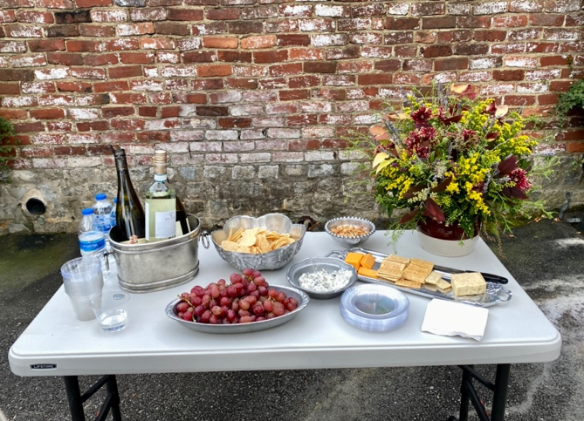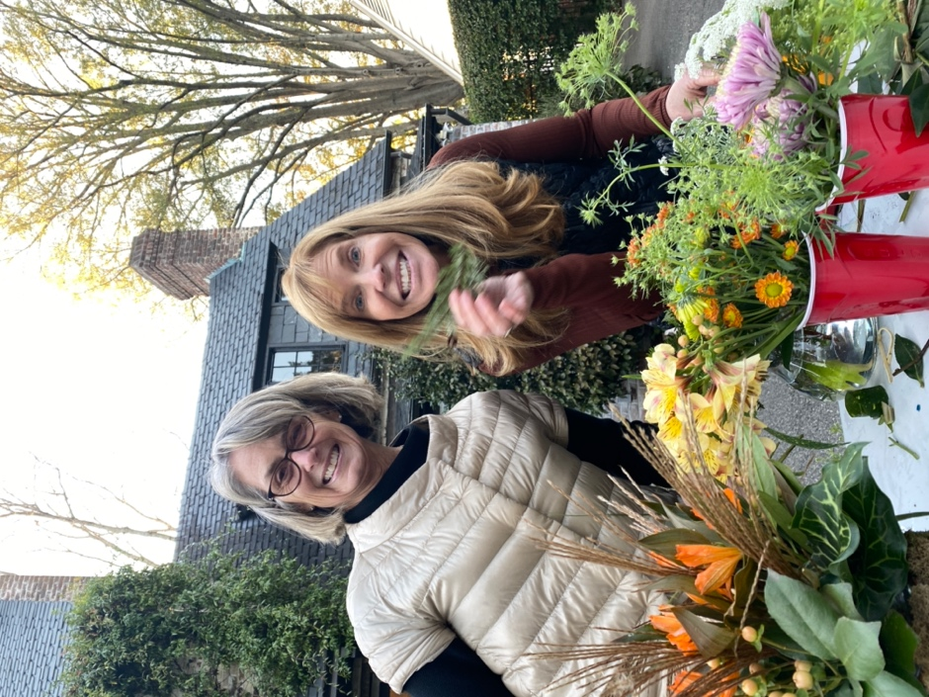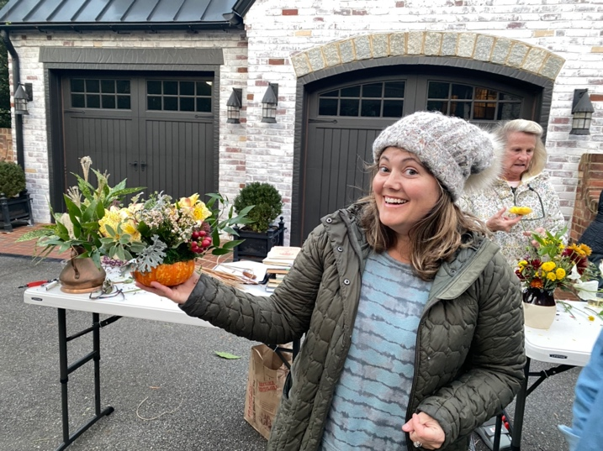
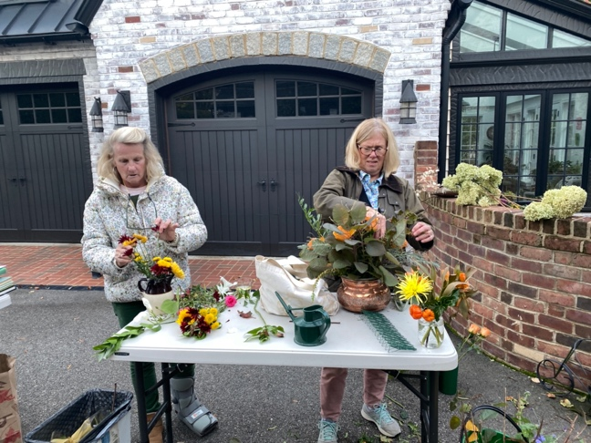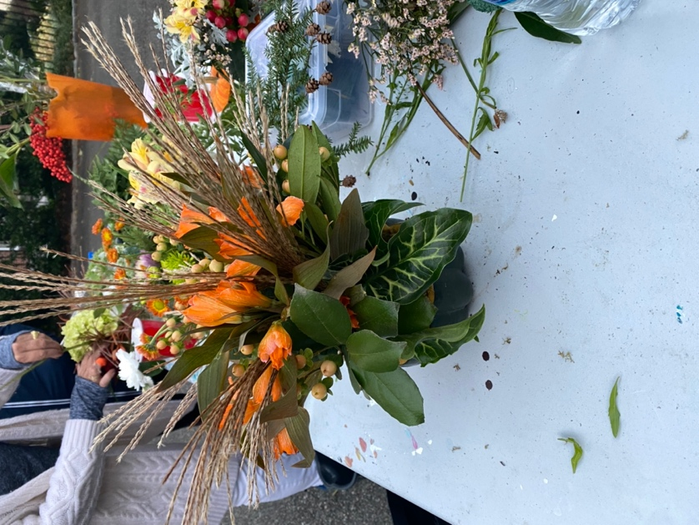

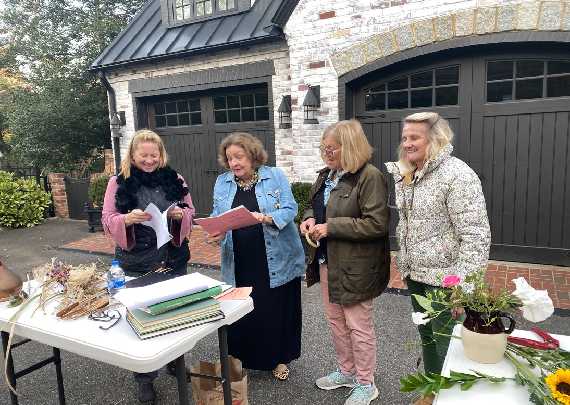

HOLIDAY GREENS WORKSHOP December 1, 2022
January